Telecommunication Equipment Distribution Program
Captioned Phones |  | Apple iPad Air 2
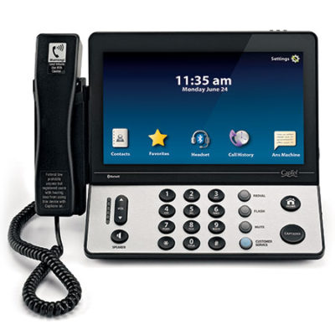 | 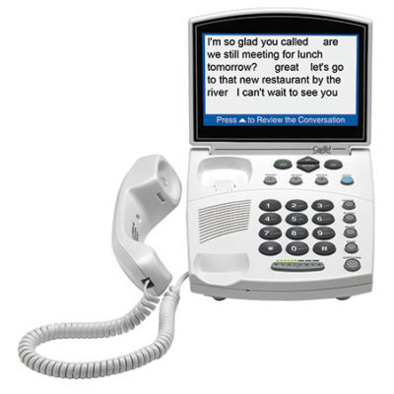 | 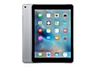
Captel 2400i | Captel 840+/840i

Amplified Phones
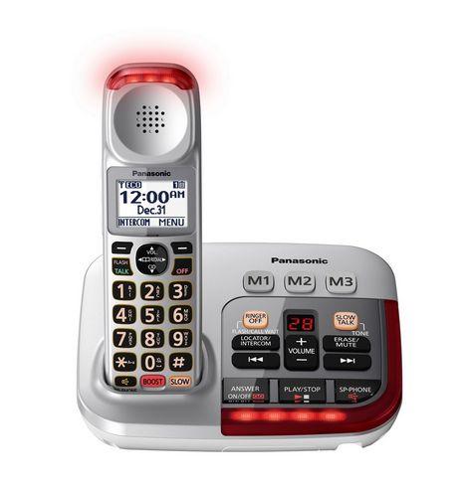 | 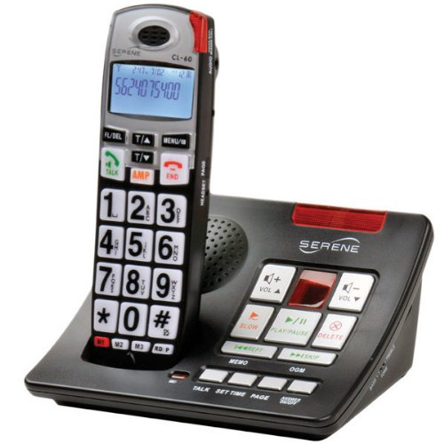 | 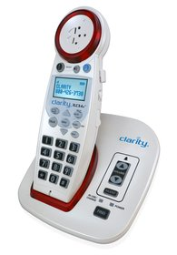 | 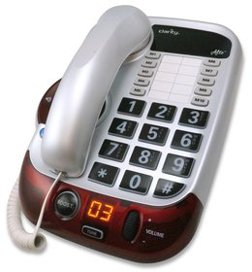 | 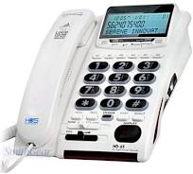 | 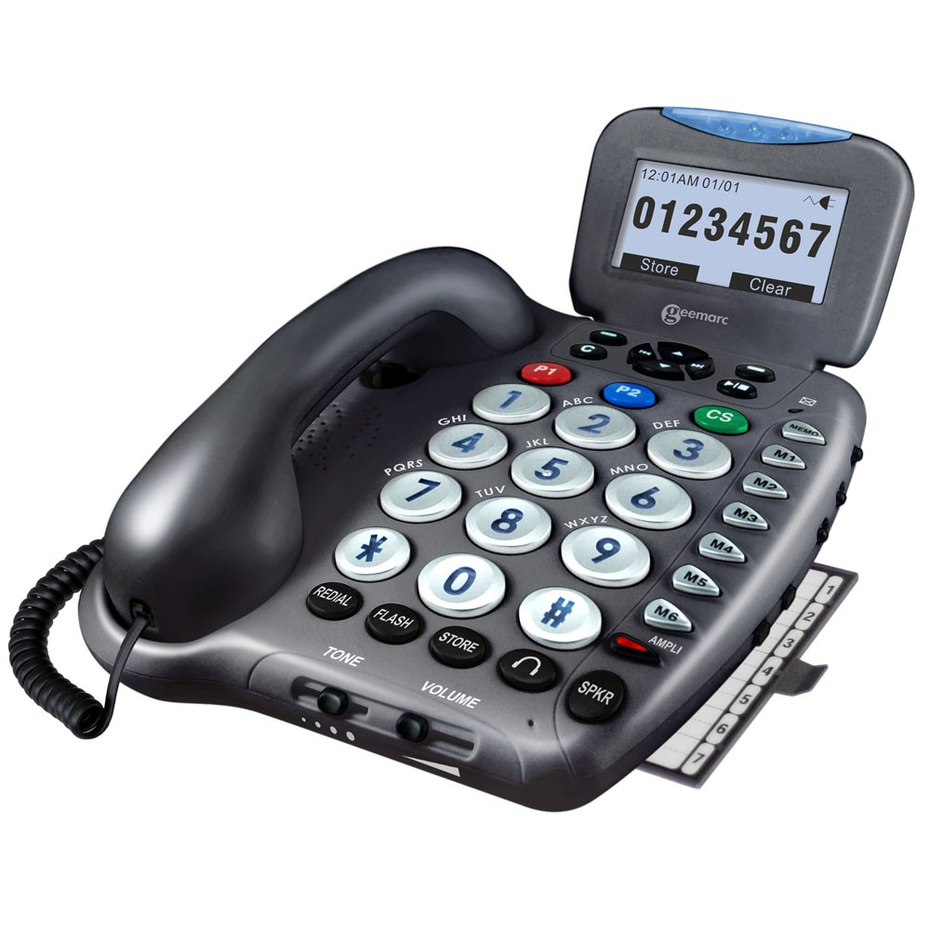
Panasonic KX-TGM 450 | Serene CL-60A | Clarity XLC3.4 | Clarity Alto | Serene HD65 | Geemarc 555

Alerting Devices
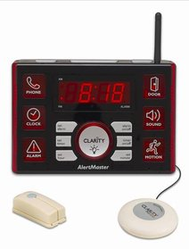  Alertmaster AL10 | 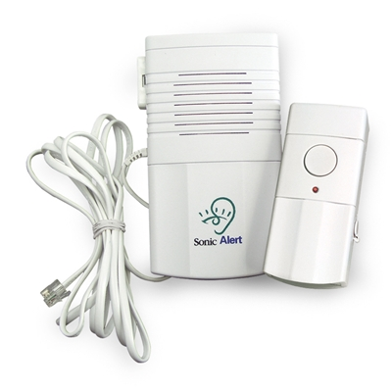  SonicAlert DB200

Speech Equipment
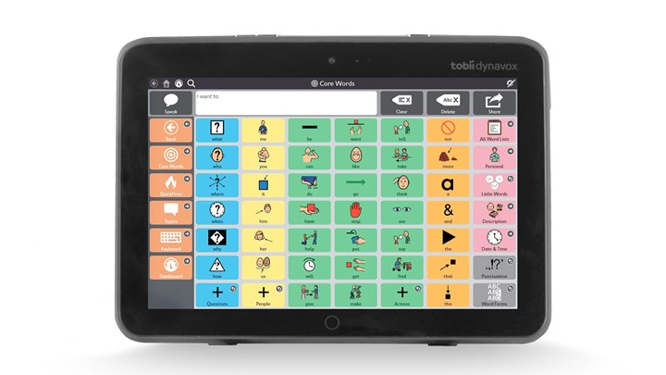 | 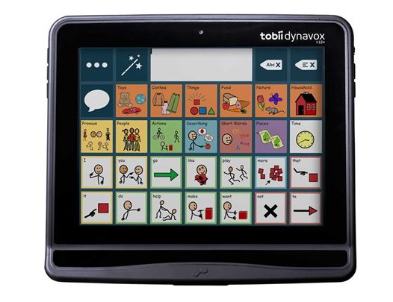 | 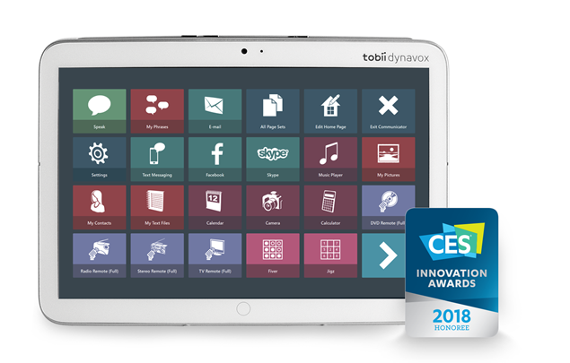 | 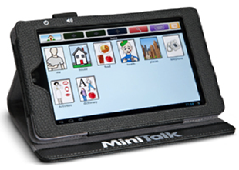 | 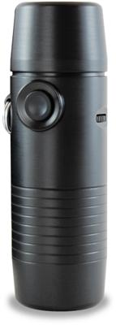
Tobii-Dynavox I-110 | Tobii-Dynavox I-12 | Tobii-Dynavox Indi | Lingraphica MiniTalk | Griffin TruTone

