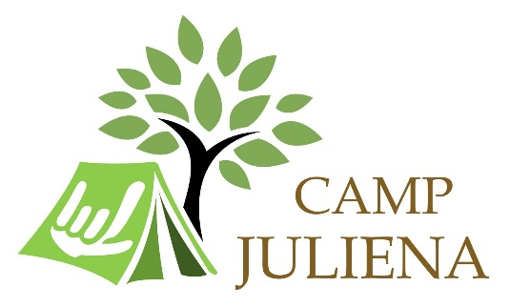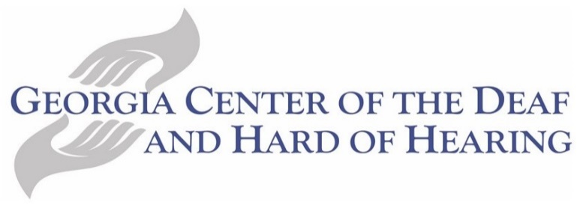

Volunteer Application

Youth Camp Juliena is a week-long residential summer camp for kids ages 6-13 that are Deaf or Hard of Hearing. Through challenging and fun activities, campers form lasting friendships and acquire valuable leadership, team- building, social and communication skills. Summer is fast approaching so apply to be a volunteer today!

Name:____________________________________________________
Age:______________________________________________________
City/State:_________________________________________________
Email:_____________________________________________________
Your signing skills:___________________________________________

Why do you want to apply to be Camp Juliena Staff?

Camp Juliena Director will contact you for an interview.

